Lesson 06 Bootstrap Hands On

**Lesson 6 Practice Hands-On**

**Directions**

For your Lesson 6 Practice Hands-On, you will be practicing your new skills working with Bootstrap. This Hands-On will not be graded, but we encourage you to complete it. The best way to become a great programmer is to practice! Because this project will be very different for each student completing it, the solution following this project may look different than yours.

Setup

1. Open up your terminal/command prompt.
2. Navigate to your desktop in your terminal.
3. cd Desktop
4. Next, navigate to the FullStackWeb directory in your terminal.
5. cd FullStackWeb
6. Then, navigate to the FrontEndFoundations directory in your terminal.
7. cd FrontEndFoundations
8. Create a new project folder named L06HandsOn located within the FrontEndFoundations folder in your terminal.
9. mkdir L06HandsOn
10. Once the process is complete, navigate into the L06HandsOn directory:
11. cd L06HandsOn
12. Run the following to open your new project in VS Code (or you can open the folder within VS Code directly):
13. code .
14. Create two new files: index.html and style.css in VSCode by selecting the add file button shown below :

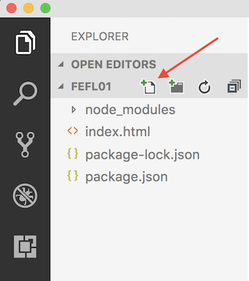

1. Link your CSS file to your HTML file using <link rel="stylesheet" href="style.css">

Requirements

Use the Bootstrap CDN to bring Bootstrap into your project.

Step 1

Using your new knowledge of Bootstrap to create a web page that contains the following:

* A Form that includes:
  + First Name input
  + Last Name input
  + Phone Number input
  + Email input
  + Submit Button
  + Cancel Button
* Your First Name and Last Name inputs should appear in the same row with "Full Name" as the prepended text. (No label elements should be use for First and Last names)
* Your form should use form groups and input groups to group the labels of the other inputs.
* Add a paragraph about yourself after the form along with your picture.
* Use the grid system and breakpoints to make the picture appear above your bio when the screen is small, and side by side when the screen is medium sized or larger.
* Use a theme from [www.bootstrapcdn.com/bootswatch/](https://www.bootstrapcdn.com/bootswatch/) instead of the default theme

Example

**Full Screen Size:**

**Small Screen Size:**